Title: Summary of NGO Activities

# **Activities:**

**1)Food Distribution Activity:**

**Description:** This activity aims to support communities in need by organizing food distribution drives that provide nutritious meals and essential supplies. Participants engage in planning, collecting, packaging, and distributing food items to underprivileged individuals or families. The initiative promotes empathy, social responsibility, and active community involvement.

Objectives:

* 1. Promote compassion and a sense of social responsibility.
  2. Address food insecurity and hunger in the community.
  3. Foster teamwork and organizational skills among participants.

# Activities:

1. Organizing distribution camps.
2. Food collection and donation drives.

# Achievements:

1. Provided meals and support to numerous individuals and families.
2. Strengthened community bonds and volunteer engagement.

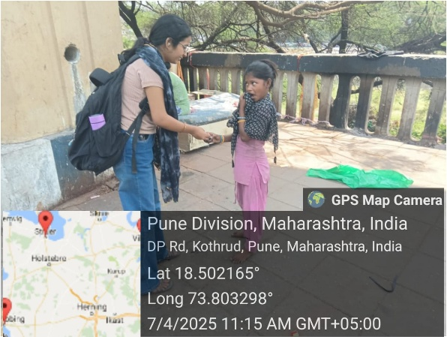

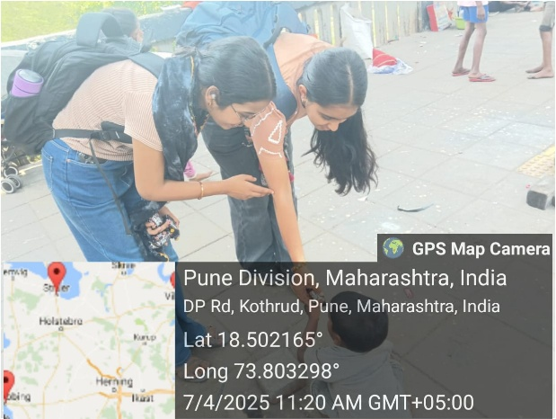

# 2)**River cleaning:**

Description: This activity emphasizes environmental caring by engaging participants in cleaning and restoring the health of local rivers. It aims to raise awareness about water pollution and encourage community involvement in protecting natural water bodies. Participants take part in organized clean-up drives, awareness campaigns, and sustainable waste management practices under expert supervision and local collaboration.

Objectives:

* 1. Promote environmental awareness and responsibility.
  2. Improve the cleanliness and ecological health of rivers..
  3. Encourage community participation in sustainable practices.

# Activities:

1. Riverbank clean-up drives and waste collection.
2. water pollution and conservation.

# Achievements

1. Reduced pollution levels in targeted river areas.
2. Increased public awareness about the importance of clean water bodies.
3. Opportunities for personal growth and artistic development.

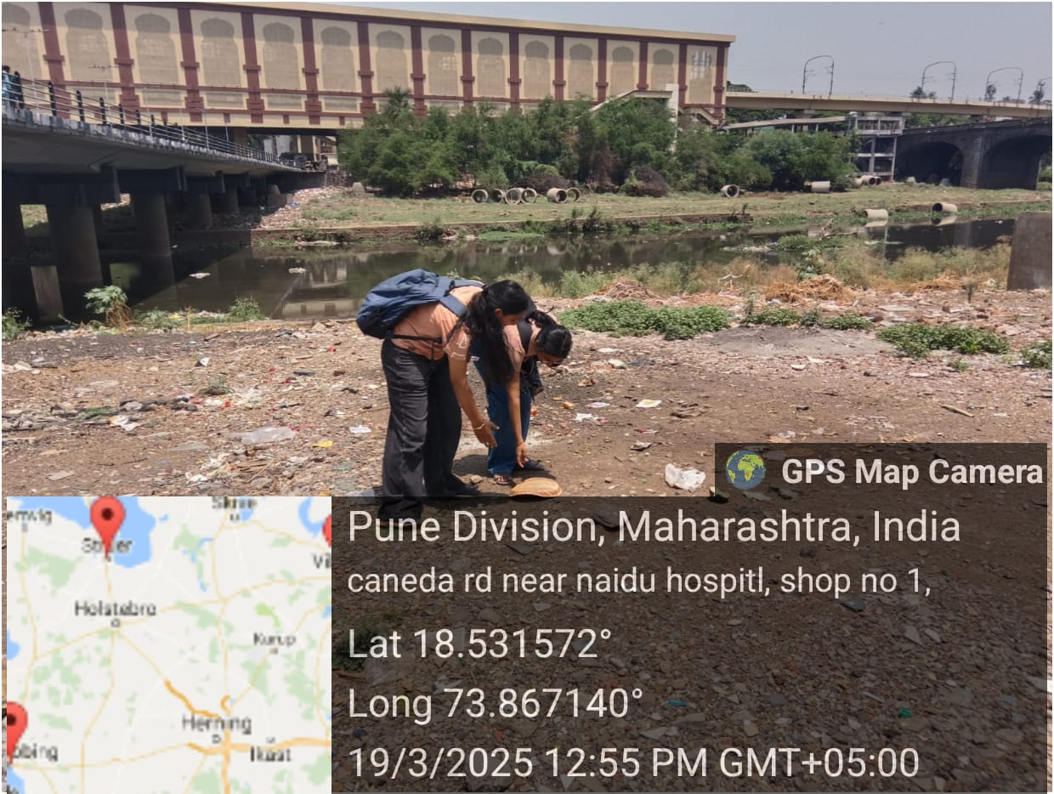

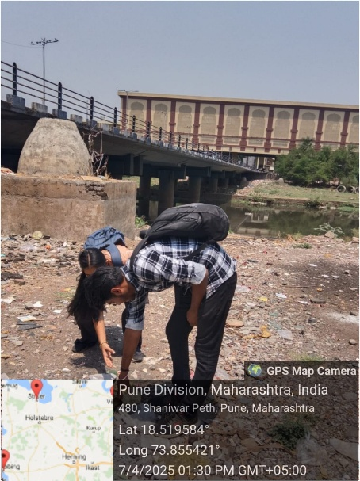

# 3)Garbage Cleaning:

**Description:** This activity focuses on promoting cleanliness and hygiene by encouraging participants to actively take part in cleaning public spaces. It provides hands-on experience in community service, helps spread awareness about proper waste management, and fosters a sense of responsibility towards a cleaner environment. Guided by coordinators and experts, participants engage in organized clean-up drives across various locations such as streets, parks, and campuses.

# Objectives:

1. Promote cleanliness and hygiene in public spaces.
2. Empower participants to become effective in cleanliness.
3. Provide opportunities for personal and professional growth.

# Activities:

1. Segregation of waste into recyclable and non-recyclable materials.
2. Community garbage collection and clean-up drives.

# Achievements:

1. Cleaner and more hygienic surroundings.
2. Increased awareness about environmental cleanliness.
3. strengthened community spirit and social responsibility.

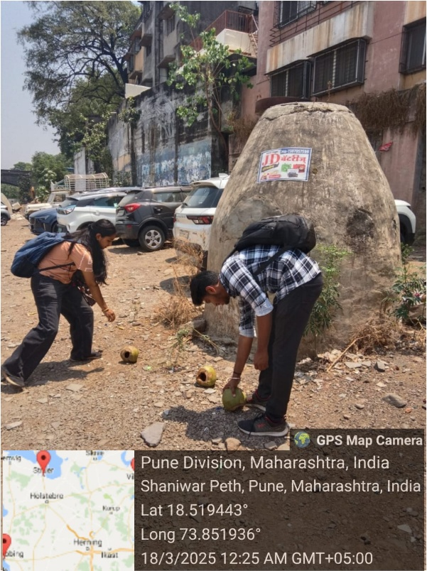

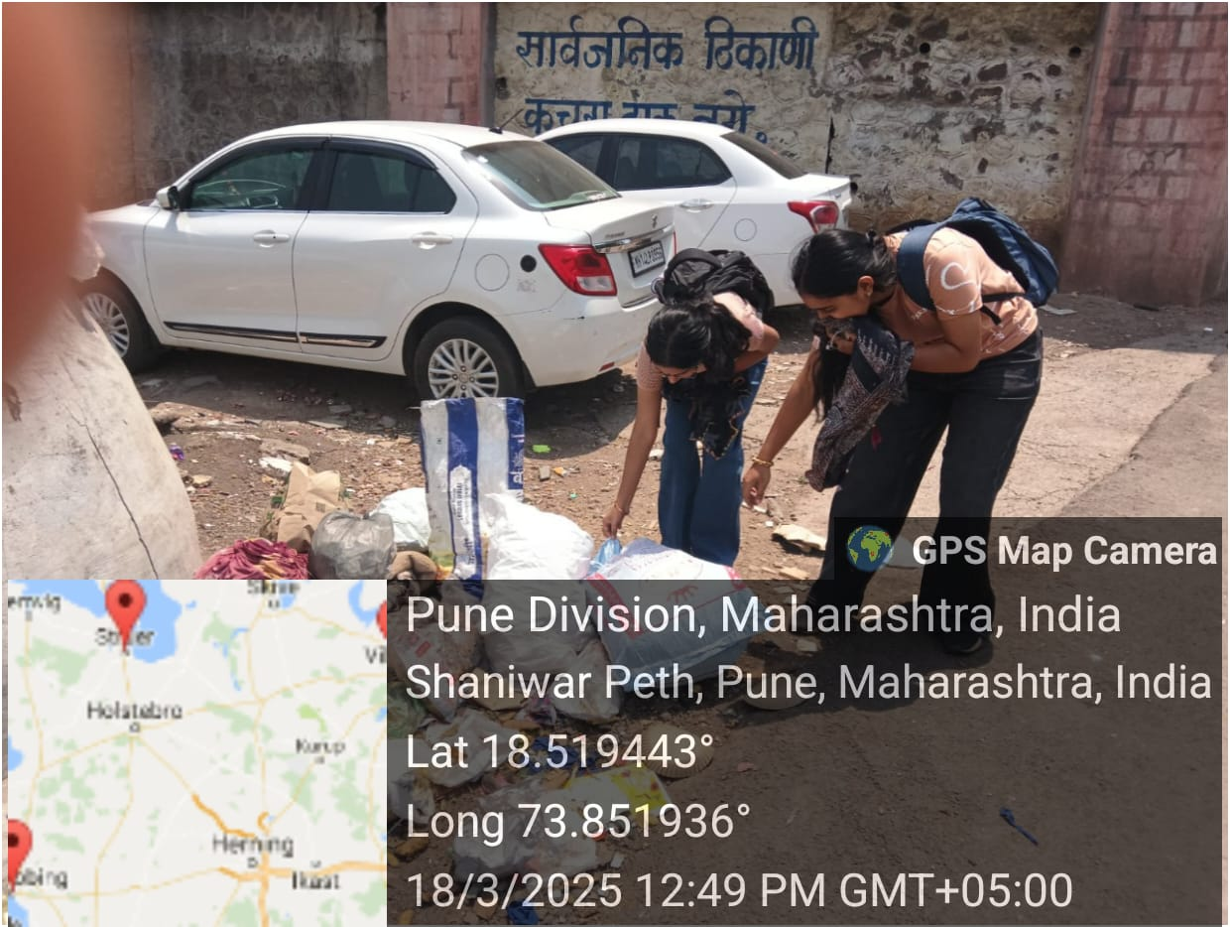

# 4) **Tree Plantation:**

Description: This activity focuses on enhancing green cover and promoting ecological balance through the planting of trees. Participants engage in planting saplings in designated areas such as schools, parks, roadside spaces, and open grounds. The initiative encourages environmental consciousness, sustainability, and community participation, with guidance provided by environmentalists and local authorities..

# Objectives:

1. Increase green cover and contribute to ecological restoration.

2. Promote awareness about the importance of trees and biodiversity.

3. Encourage sustainable and eco-friendly practices among participants.

# Activities:

1. Plantation of saplings in selected areas.
2. Maintenance drives for watering and caring for planted saplings.
3. Outdoor recreational activities.

# Achievements:

1. Increased number of trees in the community.
2. Strengthened social bonds and friendships.
3. Development of valuable life skills such as teamwork and leadership.

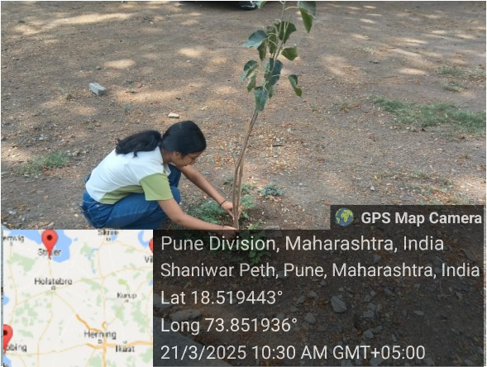

# **5)Student Discussion**

Description: This activity encourages open dialogue among students on various academic, social, and global topics. It provides a platform for sharing ideas, building communication skills, and fostering mutual respect for different perspectives. Guided by mentors or faculty, students engage in structured discussions, debates, and brainstorming sessions, promoting critical thinking and collaborative learning.

Objectives:

* 1. Develop critical thinking and effective communication skills.
  2. Encourage open-mindedness and respect for diverse opinions.

Activities:

1. Group discussions on current affairs, academic topics, or social issues.
2. Reflection rounds to summarize key takeaways and perspective.

Achievement:

1. Improved articulation, listening, and reasoning abilities.
2. Fostered a culture of respectful dialogue and intellectual curiosity.

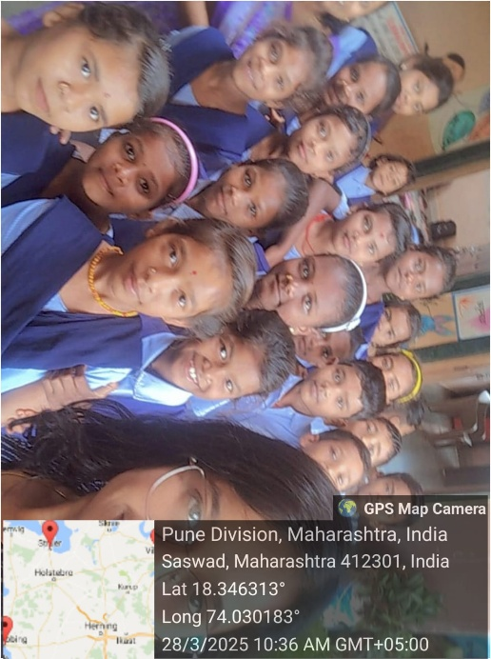

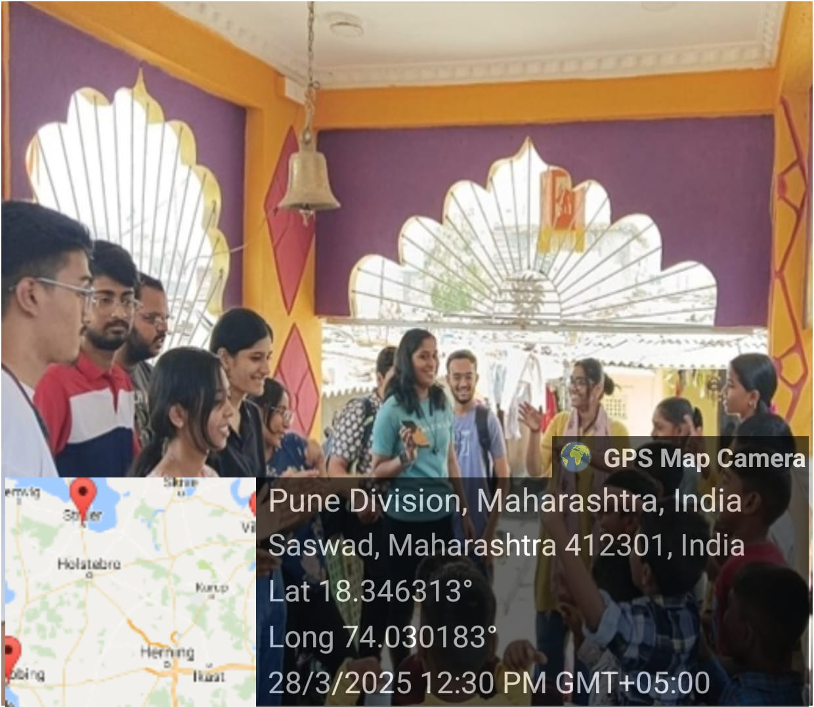

Conclusion:

Swaroopwardhinee NGO continues to uphold its mission of empowering individuals and transforming communities through education, skill development, and technology. By fostering learning environments and introducing innovative programs such as teaching , we strive to equip community members with the tools they need to succeed in the modern world. Our heartfelt thanks go out to our dedicated volunteers, supporters, and partners whose unwavering support makes our vision a reality.

Sincerely,

Vedanti Kavitkar

TY AIDS [A]